A Family Cyber Safety Quick Reference
When Belonging Becomes a Trap — Prevent your family from becoming a target
Critical thinking + Guardrails + Safe disclosure = Resilience
Cyber safety is a family activity
Most online harm to kids doesn't look like a stranger, and it doesn't look like a threat — it looks like someone who finally gets them. That's the real pattern behind grooming, sextortion, and scams: exploiting the ordinary need to be noticed, accepted, and believed. AI just makes it cheaper and more convincing to fake. This isn't about suspecting everyone your child talks to — it's about recognizing when connection turns into control, and knowing exactly what to do next.

Practice this with your family, regularly:
Think and ask before you act
• Who is making this claim, and how do we know it's really them?
• What do they want us to feel or do — right now, in a hurry?
• What information is missing?
• Can we verify it outside the message itself, before acting?
An appealing story is not automatically a true story. Urgency is not automatically an emergency.

Say this — and mean it
“No person who cares about you will require secrecy, inappropriate photos, self-harm, cruelty, money, proof of loyalty, or isolation from people who protect you. If someone asks for those things, bring it to me. You will not be in trouble for telling me.”
Safety first. Consequences can wait.

If a child receives coercive, sexualized, or threatening content
1. Stop. Don't send more images, money, passwords, or personal information. Don't pay or try to appease the person.
2. Save. Preserve usernames, messages, dates, threats, and screenshots. Don't delete the account or conversation.
3. Tell. Bring in a trusted adult immediately — then report through the platform.
For suspected child sexual exploitation: NCMEC's CyberTipline (report.cybertip.org, 1-800-843-5678) or FBI/IC3 (ic3.gov).
If there is immediate danger, call 911.

 | Scan for the full guide
  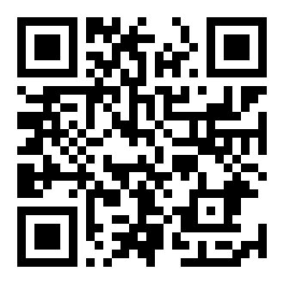  Full Guide | Add your school counselor, district safeguarding contact, or local child-advocacy center here. | 

